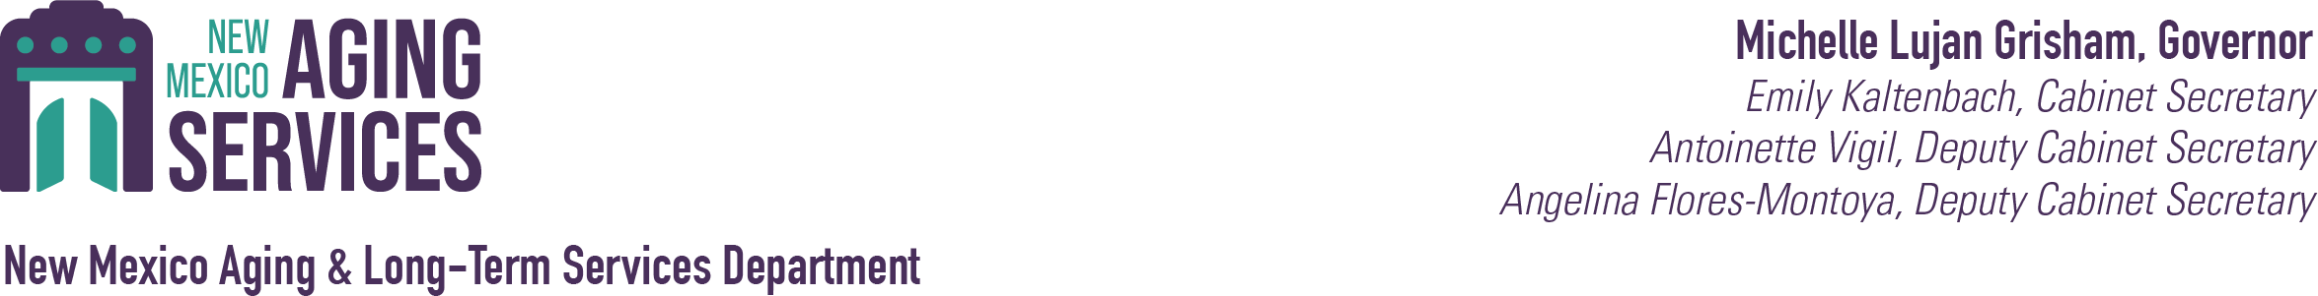

Emergency Grant Application Process

- Submit the attached application along with quotes.
- Application is received, reviewed, and signed/approved by the Capital Outlay Bureau Chief
- An emergency grant agreement (EGA) is produced and is routed with your application for review by ﬁnance, legal, and our deputy secretary.
- Once EGA is reviewed, it will be sent to you for signature by a certifying official (i.e., mayor or governor (TPNs)) and returned to Capital Outlay.
- The signed EGA is forwarded to our deputy secretary for signature and full execution.
- Once the fully executed EGA is received, you will submit your NOO (a blank copy will be sent with your fully executed emergency grant agreement) with your quotes.
- Once you receive the approved, signed, NOO, you may proceed with your purchase.
- Once the purchase is complete and paid you must submit your request for payment (RFP) immediately but no later than 30 days from the date of purchase, again a blank copy of the RFP will be attached to your fully executed emergency grant agreement, with the required supporting documents listed on page two of the RFP. Page two of the RFP is for your use only and does not need to be submitted with the RFP packet.

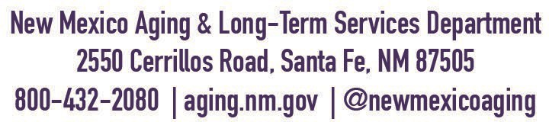


Aging and Long-Term Services (ALTSD) Request for Statewide Funding EMERGENCY APPLICATION

In Laws 2024 Chapter 66, Section 4, Paragraph 15 - $1,000,000 was identified for FY2024 through FY2028 for emergency requests to plan, design, renovate, improve, equip, and furnish senior centers, including delivery and installation of building systems and purchase and installation of meals equipment, and purchase and equip vehicles for senior centers statewide.

ALTSD is seeking requests for funding that did not meet the $10K threshold for capital outlay funding through the normal application process, or a project request that demonstrates an urgent or critical need to carry out a service offered at the senior center, and that without the asset, would disrupt a senior center from operating or failure is imminent.

Use of the asset must comply with NM Constitution Article IX, Section 14 (Anti-Donation Clause). A license to use agreement must be in place to allow non-profit provider use of the asset. The asset must meet the useful life criteria of 7 - 10 years. The assets must be maintained by the local public body. Capital outlay funds cannot be used for indirect program costs or operating expenses, and items that are not tangible.

The local public body must agree to the conditions and restrictions of the grant agreement. The expense must be made, and reimbursement of qualifying expenses submitted on the prescribed forms, including the copy of the purchase order, copy of the invoice and copy of the cancelled check within the quarter the expense was made.

DATE:

APPLICANT NAME: CONTACT NAME:
CENTER NAME and
ADDRESS

PHONE NUMBER: EMAIL:

Asset Description:
Provide a brief description of the condition and age of the old asset, and justification for the new needed asset.

COST OF ASSETS: $ (Include delivery & installation if applicable).
TOTAL REQUESTED AMOUNT: $

Briefly describe outcome, if funds are not received, and what services will be disrupted and how many seniors will be affected.

PRINTED NAME: PRINTED NAME:

AUTHORIZED OFFICIAL SIGNATURE: CAPITAL OUTLAY BUREAU CHIEF SIGNATURE

*Estimates or quotes must be attached in support of this request.

